1-Website

✅ What is a Website?
# Source: Chatgpt (GPT‑5 Mini) at [1/14/2026]
A Website is a collection of related web pages that are hosted on a server and accessed through a web browser using a domain name (like example.com).
It’s like a digital book or storefront that shows content (text, images, videos) on the Internet.

🧭 Example Websites:
# Source: Chatgpt (GPT‑5 Mini) at [1/14/2026]
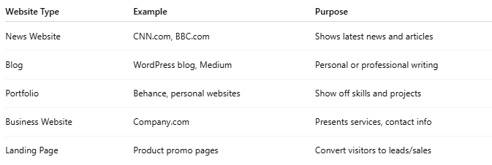
Website Type | Example | Purpose
News Website | CNN.com, BBC.com | Shows latest news and articles
Blog | WordPress blog, Medium | Personal or professional writing
Portfolio | Behance, personal websites | Show off skills and projects
Business Website | Company.com | Presents services, contact info
Landing Page | Product promo pages | Convert visitors to leads/sales

🧱 What is a Website Made Of?
# Source: Chatgpt (GPT‑5 Mini) at [1/14/2026]
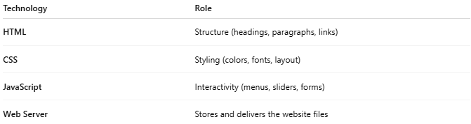
Technology | Role
HTML | Structure (headings, paragraphs, links)
CSS | Styling (colors, fonts, layout)
JavaScript | Interactivity (menus, sliders, forms)
Web Server | Stores and delivers the website files

📶 How a Website Works:
# Source: Chatgpt (GPT‑5 Mini) at [1/14/2026]
- You type example.com in your browser
- The browser sends a request to the web server
- The server responds with HTML/CSS/JS files
- The browser renders and displays the page

🕵️‍♂️ Website vs Web App
# Source: Chatgpt (GPT‑5 Mini) at [1/14/2026]
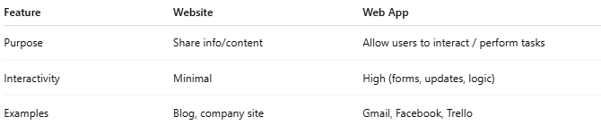
Feature | Website | Web App
Purpose | Share info/content | Allow users to interact / perform tasks
Interactivity | Minimal | High (forms, updates, logic)
Examples | Blog, company site | Gmail, Facebook, Trello

🧠 Summary
# Source: Chatgpt (GPT‑5 Mini) at [1/14/2026]
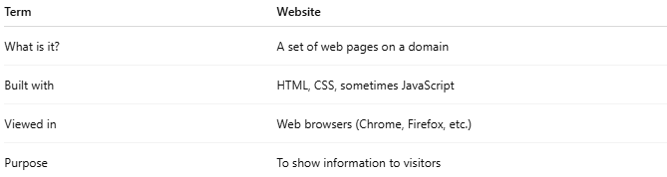
Term | Website
What is it? | A set of web pages on a domain
Built with | HTML, CSS, sometimes JavaScript
Viewed in | Web browsers (Chrome, Firefox, etc.)
Purpose | To show information to visitors

Would you like to create a simple website (like a portfolio or landing page) together step-by-step?

2-Web App

✅ What is a Web App?
# Source: Chatgpt (GPT‑5 Mini) at [1/14/2026]
A Web App (Web Application) is a software application that runs in a web browser instead of being installed on your device.
It's like a program (app), but you access and use it through a website.

🧠 Key Idea:
# Source: Chatgpt (GPT‑5 Mini) at [1/14/2026]
A website shows information
A web app lets you do things (interact, input, edit, manage)

📱 Examples of Web Apps:
# Source: Chatgpt (GPT‑5 Mini) at [1/14/2026]
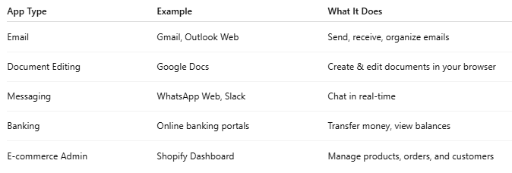
App Type | Example | What It Does
Email | Gmail, Outlook Web | Send, receive, organize emails
Document Editing | Google Docs | Create & edit documents in your browser
Messaging | WhatsApp Web, Slack | Chat in real-time
Banking | Online banking portals | Transfer money, view balances
E-commerce Admin | Shopify Dashboard | Manage products, orders, and customers

⚙️ How It Works
# Source: Chatgpt (GPT‑5 Mini) at [1/14/2026]
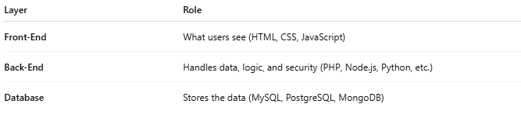
Layer | Role
Front-End | What users see (HTML, CSS, JavaScript)
Back-End | Handles data, logic, and security (PHP, Node.js, Python, etc.)
Database | Stores the data (MySQL, PostgreSQL, MongoDB)
🧭 Example:
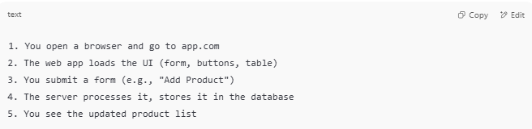
1. You open a browser and go to app.com
2. The web app loads the UI (form, buttons, table)
3. You submit a form (e.g., "Add Product")
4. The server processes it, stores it in the database
5. You see the updated product list

🧱 Web App vs Website
# Source: Chatgpt (GPT‑5 Mini) at [1/14/2026]
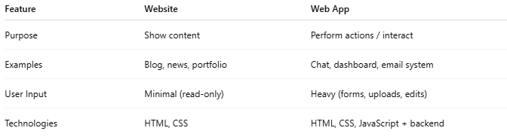
Feature | Website | Web App
Purpose | Show content | Perform actions / interact
Examples | Blog, news, portfolio | Chat, dashboard, email system
User Input | Minimal (read-only) | Heavy (forms, uploads, edits)
Technologies | HTML, CSS | HTML, CSS, JavaScript + backend

✅ Summary
# Source: Chatgpt (GPT‑5 Mini) at [1/14/2026]
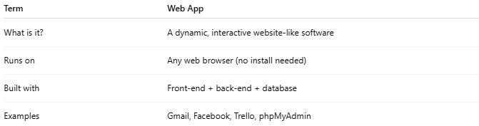
Term | Web App
What is it? | A dynamic, interactive website-like software
Runs on | Any web browser (no install needed)
Built with | Front-end + back-end + database
Examples | Gmail, Facebook, Trello, phpMyAdmin

3-Web Service

✅ What is a Web Service?
# Source: Chatgpt (GPT‑5 Mini) at [1/14/2026]
A Web Service is a software system that allows machines (computers or applications) to communicate and exchange data over the internet using standard web protocols like HTTP.
In simple terms:
A web service lets one app send or receive data from another app, remotely, through the web.

🧠 Think of it Like:
# Source: Chatgpt (GPT‑5 Mini) at [1/14/2026]
🧋 A vending machine:
- You (a program) send a request: Give me item 42
- The machine (web service) processes it and responds: Here is item 42

🧭 Real-Life Examples
# Source: Chatgpt (GPT‑5 Mini) at [1/14/2026]
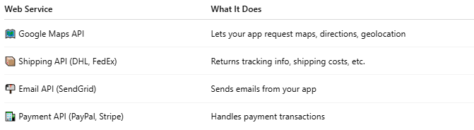
Web Service | What It Does
🗺 Google Maps API | Lets your app request maps, directions, geolocation
📦 Shipping API (DHL, FedEx) | Returns tracking info, shipping costs, etc.
📬 Email API (SendGrid) | Sends emails from your app
🏦 Payment API (PayPal, Stripe) | Handles payment transactions

🔄 How It Works:
# Source: Chatgpt (GPT‑5 Mini) at [1/14/2026]
- A client app (your code) sends a request like:
GET https://api.example.com/products/15

- The web service (server) processes it
- The server responds with data (often in JSON or XML format)

💬 Common Formats
# Source: Chatgpt (GPT‑5 Mini) at [1/14/2026]
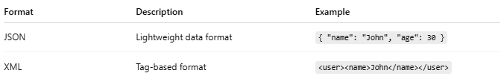
Format | Description | Example
JSON | Lightweight data format | { "name": "John", "age": 30 }
XML | Tag-based format | <user><name>John</name></user>

🔐 Standard Protocols
# Source: Chatgpt (GPT‑5 Mini) at [1/14/2026]
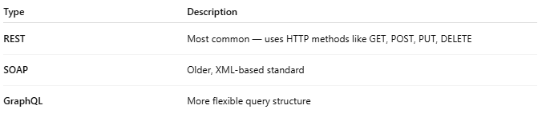
Type | Description
REST | Most common — uses HTTP methods like GET, POST, PUT, DELETE
SOAP | Older, XML-based standard
GraphQL | More flexible query structure

✅ Example: REST Web Service Call
# Source: Chatgpt (GPT‑5 Mini) at [1/14/2026]
Request:
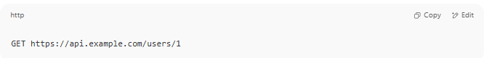
GET https://api.example.com/users/1

Response:
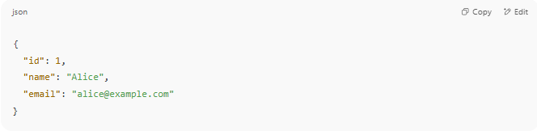
{
"id": 1,
"name": "Alice",
"email": "alice@example.com"
}

Your program can read and use this data (e.g., show the user info).

📊 Web Service vs Web App vs Website
# Source: Chatgpt (GPT‑5 Mini) at [1/14/2026]
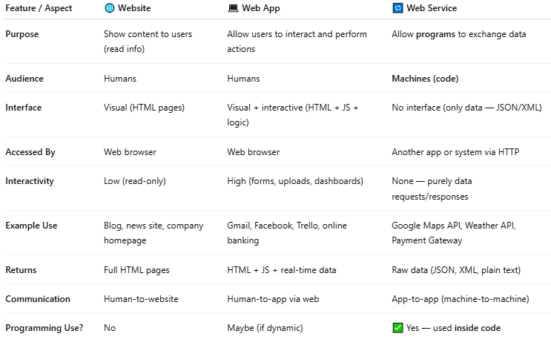

Feature / Aspect | 🌐 Website | 💻 Web App | 🔁 Web Service
Purpose | Show content to users (read info) | Allow users to interact and perform actions | Allow programs to exchange data
Audience | Humans | Humans | Machines (code)
Interface | Visual (HTML pages) | Visual + interactive (HTML + JS + logic) | No interface (only data — JSON/XML)
Accessed By | Web browser | Web browser | Another app or system via HTTP
Interactivity | Low (read-only) | High (forms, uploads, dashboards) | None — purely data requests/responses
Example Use | Blog, news site, company homepage | Gmail, Facebook, Trello, online banking | Google Maps API, Weather API, Payment Gateway
Returns | Full HTML pages | HTML + JS + real-time data | Raw data (JSON, XML, plain text)
Communication | Human-to-website | Human-to-app via web | App-to-app (machine-to-machine)
Programming Use? | No | Maybe (if dynamic) | ✅ Yes — used inside code

🧠 Simple Analogy
# Source: Chatgpt (GPT‑5 Mini) at [1/14/2026]
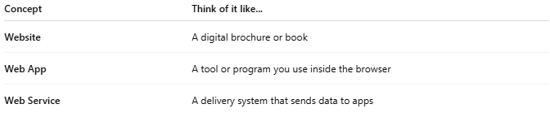

Concept | Think of it like...
Website | A digital brochure or book
Web App | A tool or program you use inside the browser
Web Service | A delivery system that sends data to apps

🧩 Example Technologies Used
# Source: Chatgpt (GPT‑5 Mini) at [1/14/2026]
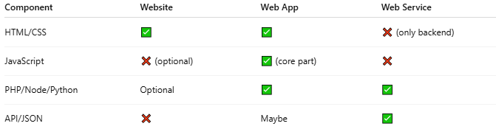

Component | Website | Web App | Web Service
HTML/CSS | ✅ | ✅ | ❌ (only backend)
JavaScript | ❌ (optional) | ✅ (core part) | ❌
PHP/Node/Python | Optional | ✅ | ✅
API/JSON | ❌ | Maybe | ✅

✅ Summary Table
# Source: Chatgpt (GPT‑5 Mini) at [1/14/2026]
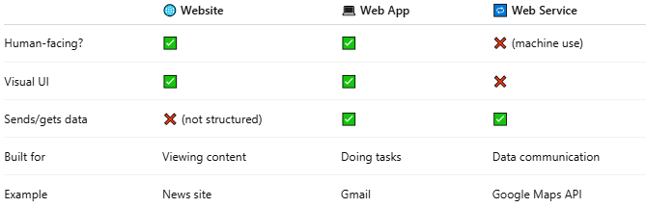

 | 🌐 Website | 💻 Web App | 🔁 Web Service
Human-facing? | ✅ | ✅ | ❌ (machine use)
Visual UI | ✅ | ✅ | ❌
Sends/gets data | ❌ (not structured) | ✅ | ✅
Built for | Viewing content | Doing tasks | Data communication
Example | News site | Gmail | Google Maps API

🧠 Summary
# Source: Chatgpt (GPT‑5 Mini) at [1/14/2026]
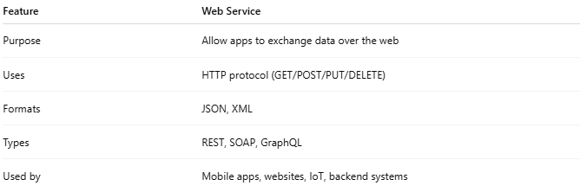
Feature | Web Service
Purpose | Allow apps to exchange data over the web
Uses | HTTP protocol (GET/POST/PUT/DELETE)
Formats | JSON, XML
Types | REST, SOAP, GraphQL
Used by | Mobile apps, websites, IoT, backend systems

